**Neoliberalism, Democracy and Development**

‘Neoliberalism is primarily about expanding the scope for human freedom’. Discuss.

1917 Words

1. Introduction

Neoliberalism has been among the main streaming ideologies in the western countries since the end of World War II. The influence of neoliberalism can be seen in advanced economies, developing economies and even political and economic interactions between countries. Maximizing and sustaining human freedom has always been one of the main goals of neoliberalism. This essay examines the origin, principles and practices of neoliberalism, and based on facts from advanced and developing economies, discusses if human freedom has been expanded as a consequence.

1. Liberalism, Neoliberalism – Believes, Principles and Policies

Neoliberalism evolved from liberalism, and therefore inherited the majority of the believed, values and principles from liberalism. It is therefore important to understand the most important facets of Liberalism to truly understand Neoliberalism.

Liberalism is at its core the belief that societies should be governed by the principles of natural law, free trade, private property rights, rule of free competition and capitalist market equilibrium, since human freedom would have been maximized in such societies [DARDOT1]. In addition it was believed that markets consist of independent, isolated economic agents, guided by considerations of their clearly understood interests, and actions of agents are guided by the competitive market [DARDOT1]. Government intervention in any aspect of these principles is therefore regarded as a distortion, and to be avoided. In addition, any government attempt to interfere the non-economic life of individuals must be resisted. These can only be implemented with a democratic political system that enables a society with self-correction abilities.

However despite these beliefs the reality in the states practiced liberalism (e.g. England and the US before the world wars) was that capitalist societies were dominated by monopolistic capitalists who controlled almost aspect of individual economic and non-economic lives through cronyism, inheritance, or otherwise non-competitive, non-market, or even political means. The other side of the reality was the mass abundance of individuals who failed to participate in the economic or political processes, because of social, economic and political constraints [DARDOT1].

Recognizing the problems of liberal theories and reality, neoliberalism both adopted the liberalism principles, such as competitive market, private property rights, free trade, etc, while also agreeing that government intervention was necessary for protecting these principles [DARDOT1, FRIEDMAN1]. Based on this reconciliation of the liberalism principles and government interventions, neo-liberalism accepts certain government interventions that would protect the liberalism principles anyway. [DARDOT1, FRIEDMAN1]. However, neoliberals seek to curb social activities that are regarded as against free market principle.

Some of the above believes and principles are not unique to neoliberalism. For example, authoritative governments, such as Germany in the 1930’s, are oppressive in the political sense, but may not control econometric activities such as production, distribution and property rights as closely and hence may have liberal economic policies [HELLER1]. What really sets neoliberalism apart from other political ideologies is the need for government intervention in order to protect the liberal principles in all aspects of social lives, including personal activities, politics and economics.

1. Neoliberalism in Practice

Various followers of the neoliberalism ideology can be found among the western countries, notably the US, after the Second World War, although none of them adopted this ideology without modifications. It is clear from section II that the motivation of neoliberalism is to find a set of rules based on which a society should function and the freedom of individuals should be protected. With this motivation, these neoliberalist countries willingly installed measures in favor of:

* Political democracy: although evolved gradually over a few decades after the Second World War, western countries protect the rights of individuals to publicize their political ideas and to elect their government representatives by vote [FRIEDMAN1]
* Free market rules under capitalism: governments protect property rights (including intellectual properties), competitions, contractual relationships in market transactions, free market principles, fair access to market information by individuals, advocate free international trade, minimal domestic industrial subsidiaries [FRIEDMAN2]
* Rule of law: the legal systems in these countries ensured laws are established on the basis of the principles of political democracy and free capitalist market. Under this guidance, laws do protect freedom of speech, freedom of market information, as well as curbing market distortions, such as anti-trust, anti-monopoly and anti-insider trading etc. [FRIEDMAN2]
* Minimal social welfare: as the means to ensure social stability, qualify individuals for the democratic political process and supply the market with quality labor, governments provided basic public education, hygiene, health services, employment benefits etc[FRIEDMAN2, FRIEDMAN3].
* Various followers of the neoliberalism ideology could be found among the western countries, notably the US, after the Second World War, although none of them adopted this ideology without modifications [FRIEDMAN2, DARDOT1].

These policies are obviously combinations of liberalism ideas (such as free market and political democracy) and acceptable government interventions (such as welfares and market distortion curbing laws). With these, neoliberals believe human freedom can be maximized.

1. Human Freedom under Neoliberalism

Over the last few decades, there had been various social, political and economic crises in the western countries that prompted them to further intervene in the economic, political and social systems. These include:

* Political democracy: limits to freedom of speech, if the speech involves spreading hate or advocating violence against the public or state
* Rules on social protections: laws to prevent child labor or other forms of exploitations of minors and dis-advantaged social groups
* Rules on constraining corporations: established strict laws and cracked done on insider trading, mis-representation of corporate financials, corporate governance mis-conducts, un-ethical business practices
* Rules constraining certain industries: establish strict regulations on oligopoly industries (e.g. utilities), strict rules for regulating financial institutions, health institutions, and industrial engaged in businesses with potential environmental impacts
* Industrial subsidies: provided subsidies on certain industries, such as renewable energy, energy production and energy storage, because of national development or political strategies, or other industries, such as agriculture, because of international trade agreements
* Trade protection: enacting of trade tariff (either as a result of trade agreements, or as a penalty on foreign imports), exchange rate manipulations in order to increase trade competitiveness
* Restrictions on import and export: embargo on certain products, such as semiconductors and software, for import or export purposes, in the name of national security, intellectual property protection or product safety
* Public goods subsidies: funding of parks, transportation system, housing, health care system and higher education
* Government engagement in economic operations: nationalization of corporations (especially in Europe), bail-out of financially distressed corporate (such as the financial institutions in 2008)
* Income re-distribution: imposing graduate tax rates, heritage tax and other taxes for the purpose of re-distributing wealth and income
* Control of individual behavior: access to information, compulsory education, consumptions (drug, alcohol, travel bans), price control (rent, minimum wages), social security programs, bans on travel (e.g. to North Korea and Cuba by various countries, certain Muslims by the US

The above is only a highly compressed list of rules and measures put together for smoothing the functioning of the political and capitalist systems advocated by the neoliberals. They yet seriously reduced human freedom in such countries, to the dismay of the neoliberals, although they are commonly agreed to be necessary [HARVEY1, RIZVI1, PACQUING1].The compromise of neoliberalists to accept “minimal” government interventions as the needed tools for protecting individual freedoms now seems to be more of a way for protecting the capitalist system and political democracy instead. Individuals now need to go through a long list of constraints before exercising his “freedom” in the neoliberalist society, which effectively is another brand for capitalism. But there are commonly acknowledged political, economic and societal problems that are not even mentioned by this list.

The disproportionate influence in politics and economic affairs by wealthy individuals, and the limited life opportunities available for disadvantaged individuals, for example, are some of the intrinsic problems of capitalism, a system the neoliberals regard as essential for human freedom. The neoliberals chose to down-play the causality between person background, development and later life achievements of individuals, but as can be illustrate with a simple representation of these causality relationships, individual freedom of choice is compromised, and a lot of social problems created, because of them. Figure 1 illustrates how person background, categorized as education, community and resource available, affects person development in politics and economics (in terms of the opportunity available and the ability of the individual to make correct judgments). It is hard to argue against the notion that personal development is closely related to the exercising of freedoms in politics and economics (except in regards to the few royal families, of course).

In this simple illustration, 1, a and G are taken to be good; b and M are taken to be medium; and 2, c and F are taken to be bad.

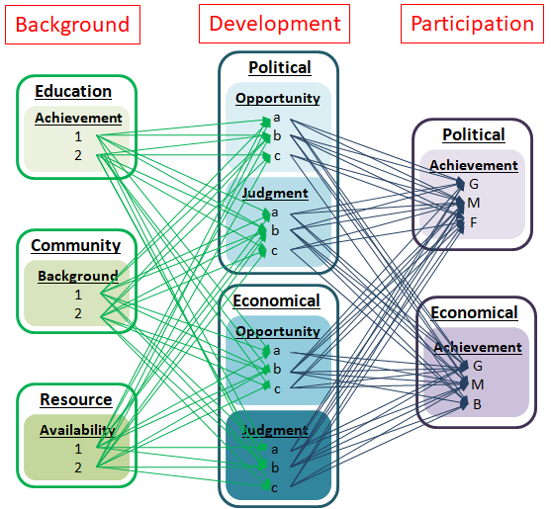

**Figure 1:** The causality relationship between personal background, development and achievements in politics and personal economics on an individual in a market economy.

It is assumed, reasonably, that good personal development is a result of good education, community and resources available in general, and bad personal development is a result of the combined effects of bad education, community and scarce resources available for average individuals (Table 1). Everything else are categorized in the medium ranking, b.

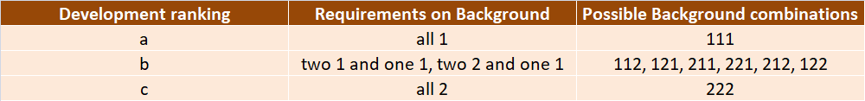

**Table 1:** The personal background combinations leading to the personal development rankings.

Based on the personal development rankings with good available opportunities and the ability to make good judgments in both politics and economics (i.e. a), the chance of that individual to achieve high in life is good (i.e. G), but on the contrary, the chance of somebody with bad personal development (i.e. rank c) as a result of low education, community and resource rankings to achieve high basically does not exist (Table 2). The most likely outcome with the later, even if he chooses to exercise the freedom of achieving high, by, say doing well in education, is medium (i.e. M).

This illustration is hardly to anybody’s surprise. It would be hard to imagine, and certainly has been verified in history, that the homeless boys wondering around the railway stations have the same probability to become good politicians or billionaires compared to those living in nice mansions, although the boys around railway stations probably have even stronger desires to exercise this freedom.

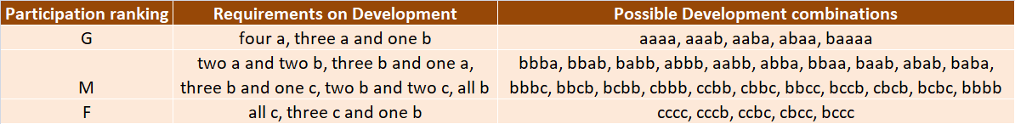

**Table 2:** Combinations of personal development rankings that lead to the political and economic participation rankings of an individual in a market economy.

The inability of and lack of opportunity available to individuals in the market to exercise freedom is assumed to have been due to market imperfections, and that is why neoliberals can agree to certain government interventions. But as long as inequality exists in the market, which neoliberals are not interested in resolving if it does not affect the functioning of the capitalist system, differential freedom will also persist. From this perspective, neoliberalism may have the good intention of maximizing human freedom but it has not issued the correct political and economic prescriptions for doing so.

1. Conclusion

It may be the goal of neoliberalism to maximize human freedom in a capitalist society. But there are intrinsic problems preventing individuals to exercise such freedoms, such that certain government interventions for solving problems are accepted by neoliberals. Some of these interventions seriously compromise individual freedoms. The readiness of neoliberals to sacrifice the freedoms of individuals in order to guarantee the smooth running of capitalism shows that protecting capitalism is a higher priority than preserving human freedom for them. With this fact, expanding human freedom under neolibralism is a goal, not a reality.

References

[DARDOT1] Pierre Dardot, Christian Laval, “The New Way of Life: The Neoliberal Society”, Verso (London, UK) 2009, Ch. 1.

[FRIEDMAN1] M. Friedman, “Capitalism and Freedom”, The University of Chicago Press (1982). Ch. 1

[FRIEDMAN2] M. Friedman, “Capitalism and Freedom”, The University of Chicago Press (1982). Ch. 2

[FRIEDMAN3] M. Friedman, “Capitalism and Freedom”, The University of Chicago Press (1982). Ch. 6

[HARVEY1] D. Harvey, “Neoliberalism as Creative Destruction”, Annals of the American Academy of Political and Social Science, vol. 610, March 2007, p.22

[HELLER1] H. Heller, “Authoritarian Liberalism?”, European Law Journal, Vol 21, Nov 3, May (2015), pp. 295-301

[PACQUING1] i.R.B. Pacquing, “Neoliberalism and the Paralysis of Human Rationality”, Kritike Journal, Vol 10, No 1 (June 2016), p.146.

[RIZVI1] F Rizvi, “Golbalization and the Neoliberal Imaginary of Education Reform”, UN Education Research and Foresight Working Papers, Feb, 2007